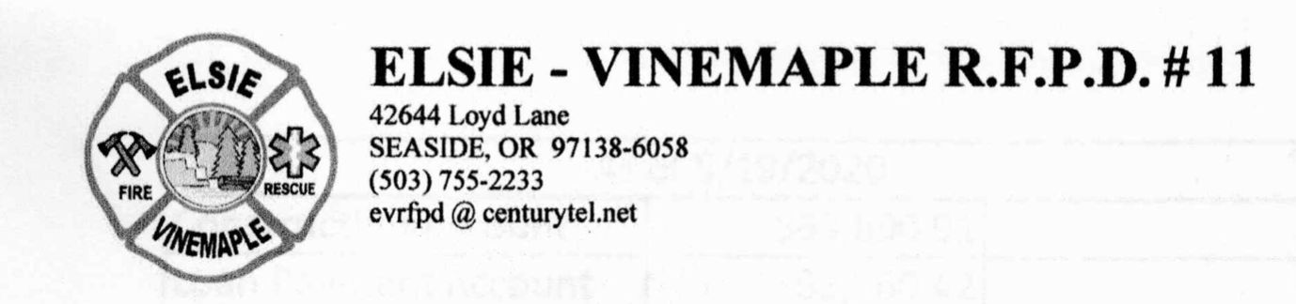

Elsie Vinemaple Fire Protection District (EVRFPD)
Special Board Meeting
February 1, 2024 5 p.m. REMOTE
Agenda

https://us06web.zoom.us/j/85110641839?pwd=QiESOp3Cyxman7dlbgRtAJ4WDeWwxc.1

- Roll Call
- Motion to authorize changes to authorized users of bank accounts

- Other Urgent Matters
- Adjourn

