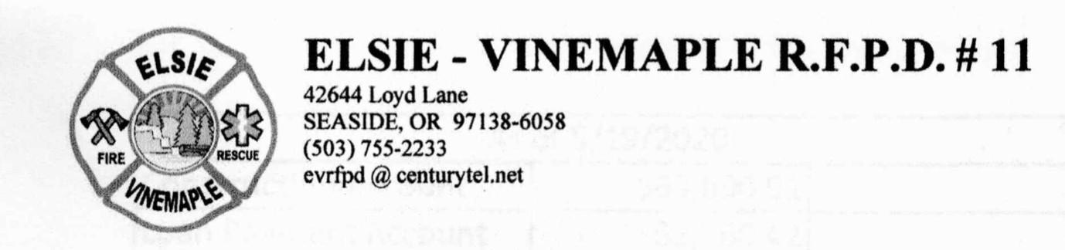

# Elsie Vinemaple Fire Protection District (EVRFPD) Monthly Board Meeting

**January 17, 2023, 6 p.m.**

**MINUTES**

1. **The meeting was called to order at 6:20 p.m.**
2. **Roll Call.** All Board members were present (Carmichael, Hecox, McCann, Morrison, Walsh). Also present was Chief Mike Wammack, and guests Susan Robinson and Joel Huckins.
3. **Approval of minutes from December 20 Meeting.** Wayne read the minutes from December 20. TJ moved to approve the minutes, Kerry seconded. Motion passed 5 yes, 0 no.
4. **Review of Accounts Payable.** 
   1. Checks to pay bills, along with the monthly expense sheet, were presented from Mike. The expense sheet matched with the checks. Kerry moved to accept the bills, and Wayne seconded. The motion passed 5-0. Checks were signed by TJ and Wayne. $20,000 will be moved from the money market account to the checking account to cover the bills.
   2. Kerry questioned the high balance of the maintenance account, which currently stands at around $12,000. The by-laws state this account should remain at $1000. This is the account that Mike and Hans can personally write checks out of to cover immediate, minor maintenance needs for fleet and building maintenance.
   3. Quick Books was discussed, focusing on the need to set it up in a way that makes more sense. Mike was asked to reorder Quickbooks software by June, so we can set it for use with the news budget beginning July 1.
5. **Reports**
   1. **Budget Report** (Mike, Staciy, Kerry).
      1. Mike presented the latest budget handout and discussed it. Internet and power bill questions from December Board meeting were discussed and settled.
      2. Staciy noted our “barebones” budget situation.
      3. The group discussed ongoing concerns about the format currently used to present the P&L overview, which is difficult to peruse. Staciy has offered to help with this and the improvement of other accounting issues, but needs access to QuickBooks to do so. Thus far, access has not been provided. It was agreed that she would meet with Mike to work on this at Station 1 on Saturday Jan 27 at noon.
      4. The Construction account has its own budget, which the Board has not seen, but needs to examine. It was noted that some of the expenditures presented in our main budget include Station 2 expenses, which should rightfully be in the Construction/Station 2 budget.
   2. **Operations Report** (Mike).
      1. Mike reported on the repairs being done to Unit 3425 at True North, authorized at the December meeting for up to $16,000. He has worked out an agreement to pay $8000 when repairs are finished, with the balance due after July 1 (approx. $8000).
      2. The tire replacement needed for 3425, estimated at $4000, will be put off until after July 1.
      3. We have three engines stored at Station 1 including Unit 3421 which is not working well. The other two Engine units-3422 and 3423 (Banks donation unit) - are in service as needed.
      4. We are not currently responding out of Station 2.
      5. Mike reported we made 26 callouts in December 2023. Kerry asked if we could get a list of callouts each month, broken down into categories (such as MVA, medical, etc.),and identified as billable/not billable. . He asked whether a Cadet might be willing to data base this for us.
      6. Mike noted that Serve Pro offered us a pallet of bottled water to help with the Evergreen Acres water problems. Costco will also supply free water (pallet) if we apply for it. Water is being stored at Station 2.

# Old Business

* 1. **Station 2**
     1. **1/12/24 Email from Deidra Pitkin regarding concerns** (TJ).
        + Deidra sent an email to TJ on January 12. She noted an alteration to a head-height brace obstruction at the top of the landing stairs that had been done recently, in violation of the Clatsop County Notice of Violation letter of Nov 7 asking all work to be stopped. She also noted that any changes need to be reviewed by engineering. In addition, she called our attention to some roof leaks and exposed insulation that could lead to future problems.
        + Mike said he had already called the roofer and expected to meet with him at Station 2 on Friday. The Board reminded Mike that we needed to get County approval for any work done, so as not to further violate their stop work order of November 7.
        + Kerry made a motion to ask Deidra to call the County and request approval to work on these needed roof repairs. TJ seconded and the motion passed 5 yes, 0 no. We also asked Mike to get a copy of the roof contract from JR Roofing so we can pursue the needed repairs when approved.
     2. **Executive session under ORS 192.660(2)(f) to consider information or records that are exempt by law from public inspection.** Kerry made a motion to leave the regular meeting and move to Executive Session at 7:30 p.m. TJ seconded, and motion passed 5 yes, 0 no. Following the executive session, at which the public was excluded, the Board reconvened the regular session at 8:10 p.m. following a motion by TJ and second by Kerry. Motion passed 5 yes, 0 no. NOTE: following the regular Board meeting a discussion of its topic was held with Chief Mike by Board members TJ and Wayne.
     3. **Review of materials from Pitkin Design** (Group). Deidra has provided a set of proposed preliminary plans for a General Scope of Work to deal with permit issues in Station 2. Deidra was not present so we agreed to postpone this item until we can meet with her at Station 2 to conduct a walk-through and discuss as a group. If we all want to attend, we will call a special meeting and open it to the public, per meeting requirements for public meetings.
  2. **EF Recovery - Review of Zoom Meeting and Decision** (Kerry and group). Kerry outlined the process by which EF Recovery gets us payment reimbursement for callouts. This information was supplemented by a January 5 handout summary from Wayne based on our zoom call with EF Recovery on January 5, 2024, from 1-1:45 p.m. TJ made a motion to have Kerry get a contract from EF Recovery so the Board can review it. Staciy seconded and motion passed 5 yes, 0 no.
  3. **Review of 2022-23 Financial Report** (Mike and group). This topic was tabled until our accountant Bill Cote could meet in person with us on our financials. Motion was made on this by TJ and seconded by Kerry, 5 yes 0 no.

# New Business. None reported.

1. **Good of the Order. None reported.**
2. **Adjourn. Kerry moved to adjourn at 8:35 p.m., seconded by Wayne. Motion passed 5 yes, 0 no.**

Page 2 of 2