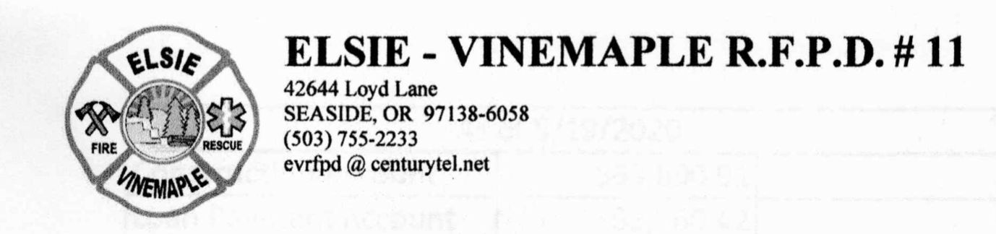

Elsie Vinemaple Fire Protection District (EVRFPD)
Special Board Meeting
February 1, 2024. 5 p.m. REMOTE Zoom

MINUTES

https://us06web.zoom.us/j/85110641839?pwd=QiESOp3Cyxman7dlbgRtAJ4WDeWwxc.1

- The meeting was called to order at 5:02 p.m.
- Roll Call. All Board members were present (Carmichael, Hecox, McCann, Morrison, Walsh). 42 community members present on Zoom.
- Motion to authorize changes to authorized users of bank accounts. Vivian read a statement, after discussion with Lewis and Clark Bank, that is needed to change authorization on the EVRFPD bank accounts. The statement reads:

A. Please remove Michael Wammack as an authorized signer and as an authorized user from all accounts. To be clear, Michael Wammack no longer has any authorization whatsoever to conduct business of any kind, including banking, on behalf of Elsie-Vinemaple RFPD.
B. Please remove Hans Mulder as an authorized signer and as an authorized user from all accounts. To be clear, Hans Mulder no longer has any authorization whatsoever to conduct business of any kind, including banking, on behalf of Elsie Vinemaple RFPD.
C. Please remove Hans Mulder from online access to all accounts as well.
D. Please add Staciy Morrison and Kerry Walsh as authorized signers and users to all Elsie Vinemaple accounts with a Tax ID number ending in 4699.
E. Please grant online access to all accounts with Tax ID number ending in 4699 to Vivian McCann, Thomas J. Hecox, and Wayne Carmichael.

Vivian asked for a motion that includes those 5 points. Kerry Walsh moved and Staciy Morrison seconded. Vote-5 in favor, 0 opposed. No discussion.

- Other Matters. The Board took this opportunity to provides update to our community as follows:
  - Ed Van Dyke, Operations Manager, read a statement that updated the Board and Community on certain items noted in working with our inventory. Quote:
We recently discovered expired medications at Station 1. Upon learning this information, a Board member contacted our supervising physician, Dr. Voeller, to get direction and advice. One of our paramedics is now tasked with being medication and supply coordinator and she is working with Dr. Voeller’s office to address and correct any improper handling or storage of medications. Dr. Voeller’s office has assured us that they are willing and able to help us see this through.
The rescue vehicle that was kept at the Chief’s house is not serviceable at this time until it is given a thorough cleaning due to mold throughout the cab.
To all our responders: We sent a text message to all of you a few days ago asking you to please return your turnouts and other district-owned property issued to you to Station 1 immediately, so we can log it into our inventory. If you are continuing to respond, that gear would remain issued to you – we just need to know who has what for inventory and transparency for the community.
We did not have a great response from the first text message, so we have set up Saturday February 3 in the afternoon, from 12 - 6, as additional time to bring in your gear to log in.
If you are unable to bring in your gear on Saturday, please contact Me-Ed Van Dyke or Kerry Walsh to schedule a time prior to this Saturday to bring in your gear since we are starting the official inventory of the Stations on Monday. A new text message will go out this evening on the Elsie Fire text message thread with the contact information of Kerry and myself.
We invite all our community members to stop in between 12 and 6 to assist in the inventory process or just to say hi and see the current state of Station 1.

  - Staciy Morrison, Board treasurer, read an update statement. Quote:

After spending a full day going through the office, we have discovered we are still missing some important documents.
Bills- We have found most of the invoices & receipts from 2023
Bank Statements- We have most of the bank statements & checks.
Credit Cards- We are still missing our credit card statements & receipts. We will continue to look for these documents. If I am unable to find these documents I will work with the bank to get copies of the statements.
  - Vivian McCann, Board Chair, read the following statements. Quote:
i. Statement from Dr. Voeller, our supervising physician.
The office has had two phone calls in the last couple days leaving messages of concern that there is a rumor that Dr. Voeller is dropping Elsie from coverage. That is not true. Dr. Voeller has no reason to do so-- he enjoys involvement in the fire service. The last thing he would want would be to leave any department in the lurch; this is even more true given Elsie's current challenges.

ii. Update on search for Interim Chief - we have several qualified candidates interested in the position. We are reviewing them now and hope to have an announcement for you soon.

iii. Some of you have asked how many of our volunteers are currently responding. We have 2 paramedics and 1 EMT responding to medical calls. For other emergency calls, we have at least 6 trained emergency responders who have responded to recent calls and/or confirmed their intent to continue responding. We have had a total of 4 calls in the last two weeks and are happy to report that each call got a quick response, with more personnel than was needed in each situation. Our own volunteers showed up, as did Mist-Birkenfeld, Banks, and Hamlet for the various calls. We extend our gratitude to all responders both in and out of our district.

Finally, we know some of you may still have questions, so we plan to hold a community meeting soon, hopefully at Jewell School, where we can share additional updates and answer questions. In the meantime, please don’t hesitate to send your questions to us by email at elsiefirewebcom@gmail.com. You can also find news about our emergency response to calls on our Facebook Page, Elsie-Vinemaple RFPD.

- Adjourn.TJ made a motion to adjourn and Wayne seconded. Motion passed 5 yes, 0 no. The meeting adjourned at 5:18 p.m.

Wayne Carmichael. Board Secretary. February 1, 2024. 7:18 p.m.

