**Elsie-Vinemaple Rural Fire Protection District**

elsiefire.specialdistrict.org **Board of Directors Meeting September 20, 2023, Minutes**

**Pledge of Allegiance**

**Board members present:** Vivian McCann (Chair),Wayne Carmichael, TJ Hecox, Staciy Morrison. Absent: Kerry Walsh.

**Fire Department members present:** Mike Wammack, Hans Mulder  
**Community Members present:** Sue Robinson, Joel Huckins

**Vivian opened the meeting at 7:20 p.m.**

**Approval of July minutes:**

Wayne read the August minutes. TJ moved to approve the minutes as read; Wayne seconded. The motion was approved 4-0.

**Review of Board Duties (per SDAO**)

Vivian reviewed Duties of the Board as presented at an Aug 21 workshop (6 hr online virtual presentation that she and Staciy attended). Workshop was run by Northwest Legal Advisors with the topic being “Special District Board Members duties, liabilities and responsibilities.”

A bulleted point outline of those duties which we intend to review over the next several months include:

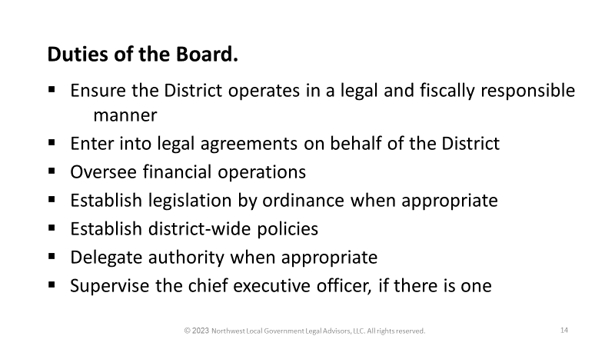

**Approval of Accounts Payable (Group)**

Vivian and TJ signed checks. One check was held back pending other bids for an on-demand hot water heater slated for Station 2. The one bid we have is from Coast Heating and Cooling for a Navien tankless water heater model NPE-240S LP. Total cost (equipment, labor, materials) $4125. Note: It was agreed Susan would check on another bid and if Coast was low then we would go with them. Susan did secure a second bid after the meeting that was more expensive, so approval was given to order the Coast Navien unit. The check, however will not be sent to the contractor until the work is complete.

**Reports**

1. **Budget Report. (Hans, Staciy).** Hans presented the budget report. No issues were found with the Aug/Sept accounts or budget, although the Board does not yet have complete understanding of the budget and accounts as they are presented. Thus, Vivian and Staciy requested holding an acceptance vote pending more interaction with Staciy and Hans over how to set accounts and the budget reporting. This followed Staciy working with Hans in Aug/Sept on how bills are processed, and loan payments are processed. Staciy explained she still needs to work out how to best to setup our accounts documents on the computer.
2. **Station 2 progress Report**
   1. Septic system updates (TJ, Mike, Wayne): Wayne updated the bid process and reported that the septic system is in and completed. We had 4 bids and the one from Mike McEwen was the low bid and was accepted. Wayne packaged a full report, consisting of bid summaries, county site assessment report, county install permit, final photos of the install and county acceptance final report. This packet was emailed to the Board so it can be recorded for future reference.
   2. Water System Updates (Mike, Wayne, Hans). Hans reported he has completed enclosures for the holding tank and filter system and the pump house. Precision has been notified to come and complete the install. We still need to install a hot water heater (see accounts payable section).

Chief’s report (Mike). Mike reported 60 plus callouts over past 2 months and that only 4 of those involved residents of the EVFRD. Mike also discussed how difficult it is to make charge backs for these callouts when they involve out of district travelers, due to several problems including delays with case reports being completed, and the lack of office help..

**Old Business**

1. Follow-up on August budget report discrepancies. (Hans). In the August budget report $403.22 was listed as income in 3 places: for donations, for Ems services, and for timber tax. Hans clarified that it was timber tax; thus, it was noted that the report should delete that amount from the other two categories, and the total income column recalculated. Upon further review, the actual source of the $403.22 was uncertain, as we didn’t have a deposit matching that amount. Hans said it was his estimate of the month’s portion of the annual timber tax income of $5000. He also said we budget $5000/year each for EMS and donations, and the $403.22 represents the single month portion of those items as well. But, one-twelfth of $5000 is $416.66, so those numbers still don’t match. Hans resolved these questions by pointing out that $5000 is from a budget estimate for the year being used in all three places and that $403.22 is 1/12 of that amount as reported for budget reporting only, not because of actual income. Hans reported the difference between $403.22 and what 1/12 should be-$416.66 was due to the computer using 31 days instead of 30 days for the length of the month.

This issue remained tabled pending better understanding and collaboration of the Board of budget processes and accounting procedures (see August minutes for vote). The Board expressed hope that Staciy and Hans will be able to set up a system that avoids these types of issues in the future.

1. Board Member Roles/ Appointments. Vivian noted we should be following Special District guidelines on Board member roles. To that end we will designate: Chair-Vivian, Vice Chair-TJ, Secretary-Wayne, Joint Treasurer-Staciy and Kerry. Vote on this was 4-0.
2. SDAO Workshop Update (Vivian, Staciy). Vivian and Staciy reported on the workshop they attended entitled, “Board Member Duties, Liabilities, and Responsibilities.” They gained a lot of information that will inform our work over the next year or so. The next SDAO next workshop is Tuesday Sept 26., on “Board Member Relations, Expectations, and Ethics. Staciy will attend.

**New Business**

1. Meeting Schedule and Location. Vivian presented two possibilities: A) changing our board dates and times. B) moving location to Station 2. Discussion concluded daytime is not good for those not retired. Wednesdays seemed to be better and 6 p.m. worked better so a 4-0 vote moved to accept next months meeting will be at 6 p.m. on Wed the 18th of October. A Station 2 move is not ready yet. Mike expressed a problem since all files, copying etc. is at station 1. It was also noted water and toilets are not in at Station 2. Also, important would be when is Station 2 ADA compliant. Hans noted that the downstairs meeting room at Station 1 is ADA compliant. We will remain at Station 1 for now.
2. Goals and Priorities. Vivian asked for comments on goals/policies. Staciy and TJ felt that accounting/budget is a priority. Wayne felt Policy discussion is an item we said we would do. Mike also felt board policy needs review.

**Adjourn**

TJ moved to adjourn the meeting. Wayne seconded. Vote 4-0. The meeting adjourned at 9:06 p.m.